

**Fi**nal Repor**t**

Super Mario Party

Anya Biryukova, Conrad Dudziak, Jordan Lawson, David Nguyen, Gabriel Smith-Dalrymple, Kayla Sprague

**Table of Contents**

**Nintendo Company Description** **3**

Mission & Philosophy 3

Organization Value & Cultures 3

Structure 3

Hiring Process & Interview Loop 4

Critical Analysis 4

Pros of the Nintendo Hiring Process 4

Cons of the Nintendo Hiring Process 4

Effectiveness of the Nintendo Hiring Process 5

Bias of the Nintendo Hiring Process 5

Developer Salary, Bonuses, Shares, Perks 5

Salary & Bonuses 5

Benefits & Perks 5

Work Environment 5

Retention Record 6

Current Litigations 6

**New Nintendo Technology: Holo Boy** **7**

Holo Boy High-Level Architecture Design 8

Holo Boy Intellectual Property 8

Holo Boy Time Table 8

Holo Boy Development Gantt Chart 9

**Holo Boy Team Structure and Skill Set** **10**

Full-Time Employee Positions 10

Hardware Engineer 10

Software Engineer 10

Systems Engineer 10

Hardware Test Engineer 10

Senior Embedded Hardware Engineer 10

Electrical Engineer 11

Full Stack Developer 11

Marketing Coordinator 11

Job Descriptions 11

Hardware Engineer Job Description 11

Software Engineer Job Description 12

Systems Engineer Job Description 12

Hardware Test Engineer Job Description 12

Senior Embedded Software Engineer Job Description 12

Electrical Engineer Job Description 13

Full Stack Developer 13

Marketing Coordinator 13

Interview Loop 14

Interview Questions 15

General Interview Questions 15

Hardware Engineer Interview Questions 15

Software Engineer Interview Questions 16

Systems Engineer Interview Questions 16

Hardware Test Engineer Interview Questions 16

Senior Embedded Software Engineer Interview Questions 17

Electrical Engineer Interview Questions 17

Full Stack Developer Interview Questions 17

Marketing Coordinator Interview Questions 17

**Skill Training** **18**

New Hires 18

Training 18

On the Job Training 18

Lectures 18

Written Material 19

**Performance Goals** **19**

Individual & Team Assessments 19

Performance Reviews 20

**Determination of Success** **21**

Key Milestones 21

Measuring Success 21

**Shipping Strategies** **22**

Challenges **23**

**Resources** **23**

# Nintendo Company Description

Nintendo is a Japanese multinational consumer electronics and video game company. Nintendo’s key products are gaming consoles and video games; they are known for creating some of the best-selling video game franchises such as *Mario,* *Pokémon*, and *The Legend of Zelda*. Their primary headquarters are located in Kyoto, Japan with an American headquarters based in Redmond, Washington. As of September 2018, Nintendo has 5,869 employees globally.

## Mission & Philosophy

Nintendo is proud to be one of the leading companies in the video-game and consumer electronics industries. The company is strongly committed to producing and marketing the highest quality products available, and holds the belief that listening closely to their customers, treating their customers with respect and consideration, is the key to creating constantly improving products and services.

Not only does Nintendo show a deep respect to their customers, they strive to carry the same values they show to their customers to their employees. By showing their employees respect, consideration, and attention, Nintendo maintains an atmosphere where talented individuals can work together to create high quality products and services.

## Organization Value & Cultures

Nintendo’s core values is to provide products and services that anyone can enjoy, regardless of age, gender, or gaming experience. They are determined to always be a company that creates entertainment that brings smiles to people’s faces.

One practice that Nintendo carries out is that they like to assign new or mid-level developers to small projects in order to come up with innovative new ideas. Games like *Super Mario Odyssey* and *1-2 Switch!* came from these small groups.

## Structure

Nintendo’s central office is located in Kyoto, Japan with two other central buildings in Japan - one that focuses on research and development in Kyoto and another focusing on manufacturing in Tokyo.

In the Redmond headquarters, there are localization, development, debugging, production, and clerical teams.

The Nintendo company has three divisions: an Entertainment Planning & Development division that focuses on game/software development for Nintendo platforms and mobile games; a “Platform Technology Development” division that focuses on operating system development and network services; and a “Business Development Division” responsible for refining Nintendo’s business model and furthering Nintendo’s development for smart devices. (Rad & Otero)

## Hiring Process & Interview Loop

The current process for getting hired at Nintendo is as follows:

1. Apply online through Nintendo’s hiring website or through a 3rd party website.
2. Receive an email confirming Nintendo’s interest and schedule a phone call with a Nintendo recruiter.
3. Go through the phone call with the Nintendo recruiter involving technical and ethical survey questions.
4. Go through an in-person interview featuring both one-on-one interviews and panel interviews with multiple people.
   1. Expect 4-5 hours of on-site engineering interviews.
   2. Prepare for multiple interviews and surveys.
   3. Practice for their technical skill testing; testing is considered fairly difficult with a heavy focus on position-related skills.
5. Go through a cultural interview to see if you are a good fit with Nintendo’s culture.
6. Receive a job offer and go through salary negotiations.

### Critical Analysis

Nintendo looks for developers who aren’t just passionate gamers, but offer a wide variety of technical and soft skills. They prefer candidates who are bilingual, being able to speak Japanese is preferred. For programming skills, they prefer candidates who can program in C++. They do like developers who are interested in Nintendo’s products, so there can be questions about what your favorite Nintendo games are and why.

#### Pros of the Nintendo Hiring Process

* Ensures that new hires are well versed in the Nintendo culture
* Guarantees that people are experts in their fields
* Looks for people that are excited to be a part of Nintendo
* Interview questions are real world scenarios

#### Cons of the Nintendo Hiring Process

* Can take a long time (2+ months) from start to finish
* Jobs can be filled by someone else while you are still in the interview process
* Often times if you don’t get the job you don’t hear back from Nintendo
* Salary range can be a bit on the low side
* Not a lot of opportunities for advancement

#### Effectiveness of the Nintendo Hiring Process

The Nintendo hiring process is rather effective, as they company only has a 3.00% turnover rate. There are reports of 8+ week interviews, which means they are thorough in making sure the candidates they hire are a good fit for the company.

#### Bias of the Nintendo Hiring Process

Nintendo has 73.9% male employees and 26.1% female employees, with a male:female managerial ratio of 4:1. This is unfortunately a highly skewed ratio compared to other tech companies like Amazon and Etsy.

2.13% of their employees have disabilities, with the legal requirement being 2.00%.

## Developer Salary, Bonuses, Shares, Perks

### Salary & Bonuses

A software engineer at Nintendo can make an approximate average of $95,708 a year with a $16,000 sign-on bonus. A senior software engineer can make approximately $122,136 a year with a $29,000 sign-on bonus.

### Benefits & Perks

* Healthcare coverage (medical, prescriptions, vision) with optional dental coverage
* Wellness program that supports healthy lifestyle choices; being tobacco-free, engaging in preventative care, being physically active
* Tuition reimbursement
* Parental/family leave and adoption assistance
* Paid time off: sick leave, vacation days, and 12 holidays
* “Healthy Living” program supports fitness and wellness related expenses
* Free or subsidized transit programs, free onsite parking, and free electric car charging
* Matches employee donations

## Work Environment

Nintendo is rather secretive about their headquarters and how work is done; tours of headquarters do not permit photography and require visitors to sign NDA’s. Most knowledge is from word of mouth or interviews from people who worked at Nintendo.

Nintendo Japan has a very traditional work environment. Work starts in the morning, 8:45 am sharp, and continues until late into the evening. The work space is filled with the classic office cubicles. They are strict on arriving to work on time and working on assigned project. However, they encouraged making game demos and being playful and creative when working on software and tasks, as long as it accomplished the goal.

Nintendo’s Redmond headquarters is said to fully designed after Nintendo IP; the parking garage is designed with Mario Kart levels in mind, the meeting rooms are designed after various video game characters. Despite the Nintendo theme, the work offices remain looking like standard business offices, but feature various displays of Nintendo products in various places.

## Retention Record

Employee retention averages at around 13.5 years. (Japan: Employee)

## Current Litigations

As of December 2018, Nintendo is suing Mikel Euskaldunak for selling modified NES Classics and Switch hacks. (Cox)

In March 2018, Gamevice is suing Nintendo under the claim that the design of the Nintendo Switch and its Joy-Con controllers infringes patents that Gamevice has on their patents for designs of controllers that slide onto console playing devices. (Good)

# 

# New Nintendo Technology: Holo Boy

Nintendo will be developing a new gaming console, the Holo Boy, that uses holographic technology to be released to consumers within 5 years. This new console allows players to experience their favorite games more interactive than ever before. Through state of the art magnetic technology and laser light technology, users are able to play games in holographic form on an extendable field of view (the laser matrix) that is always parallel between two controllers that also serve as the console device itself.

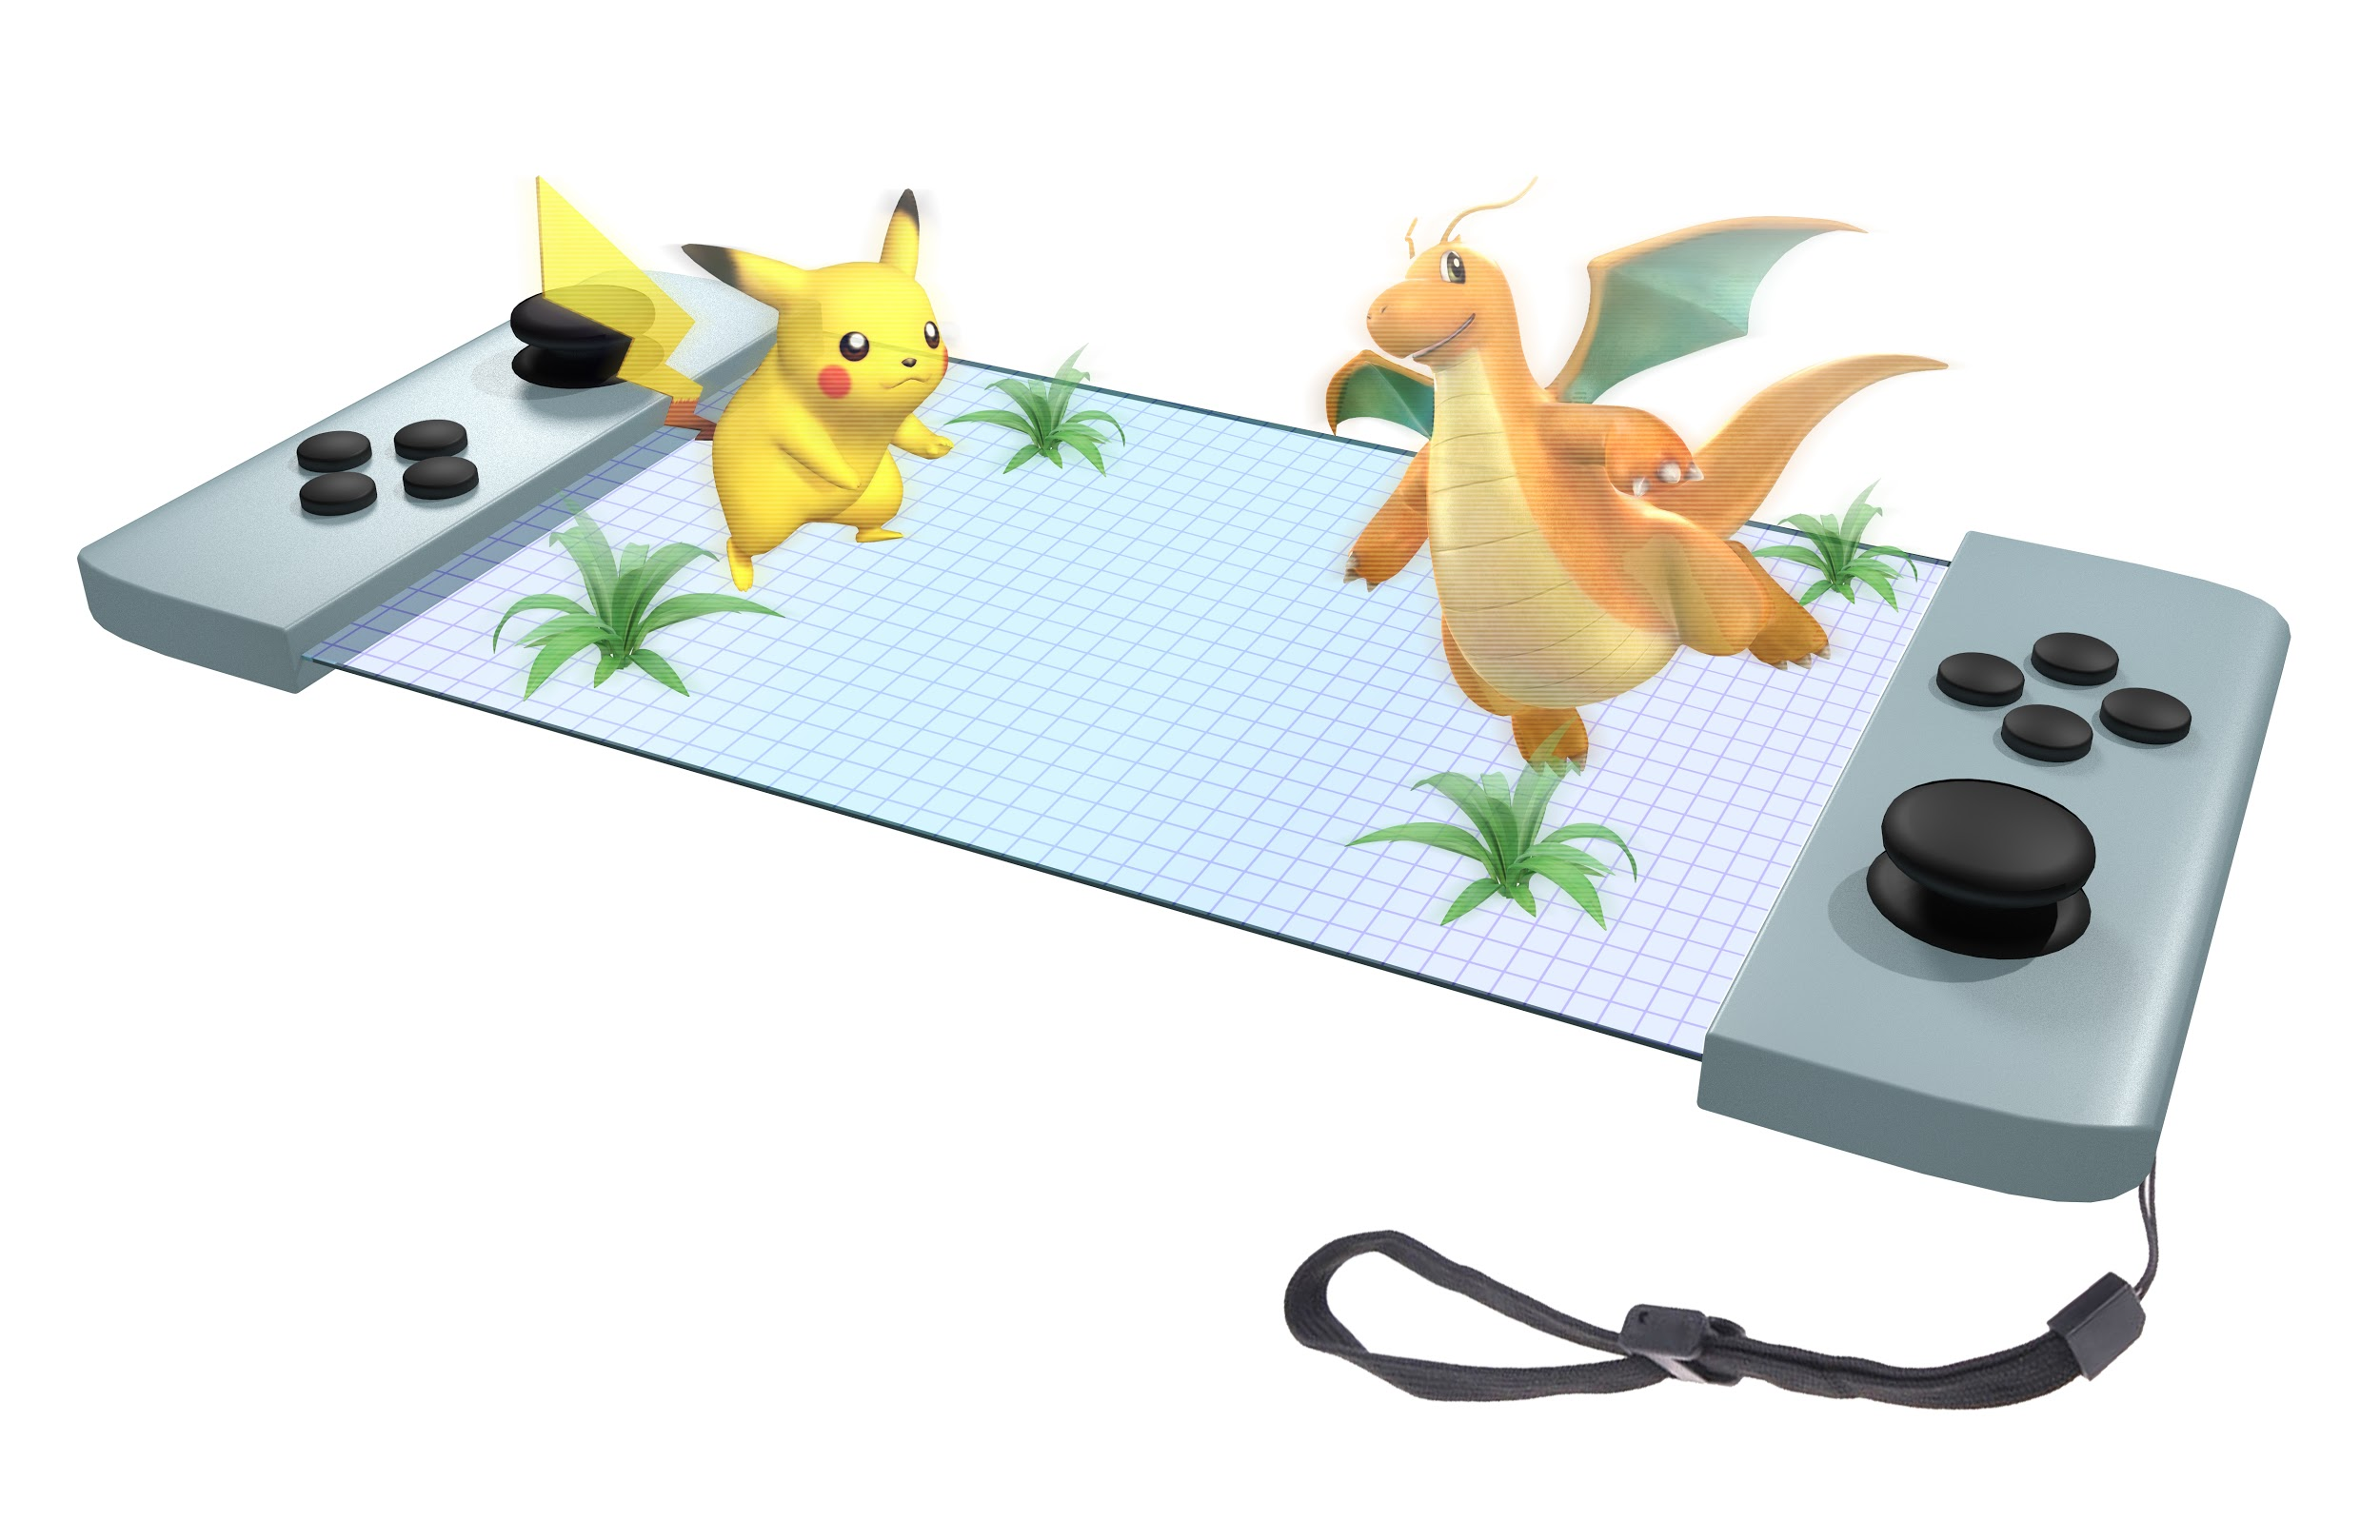

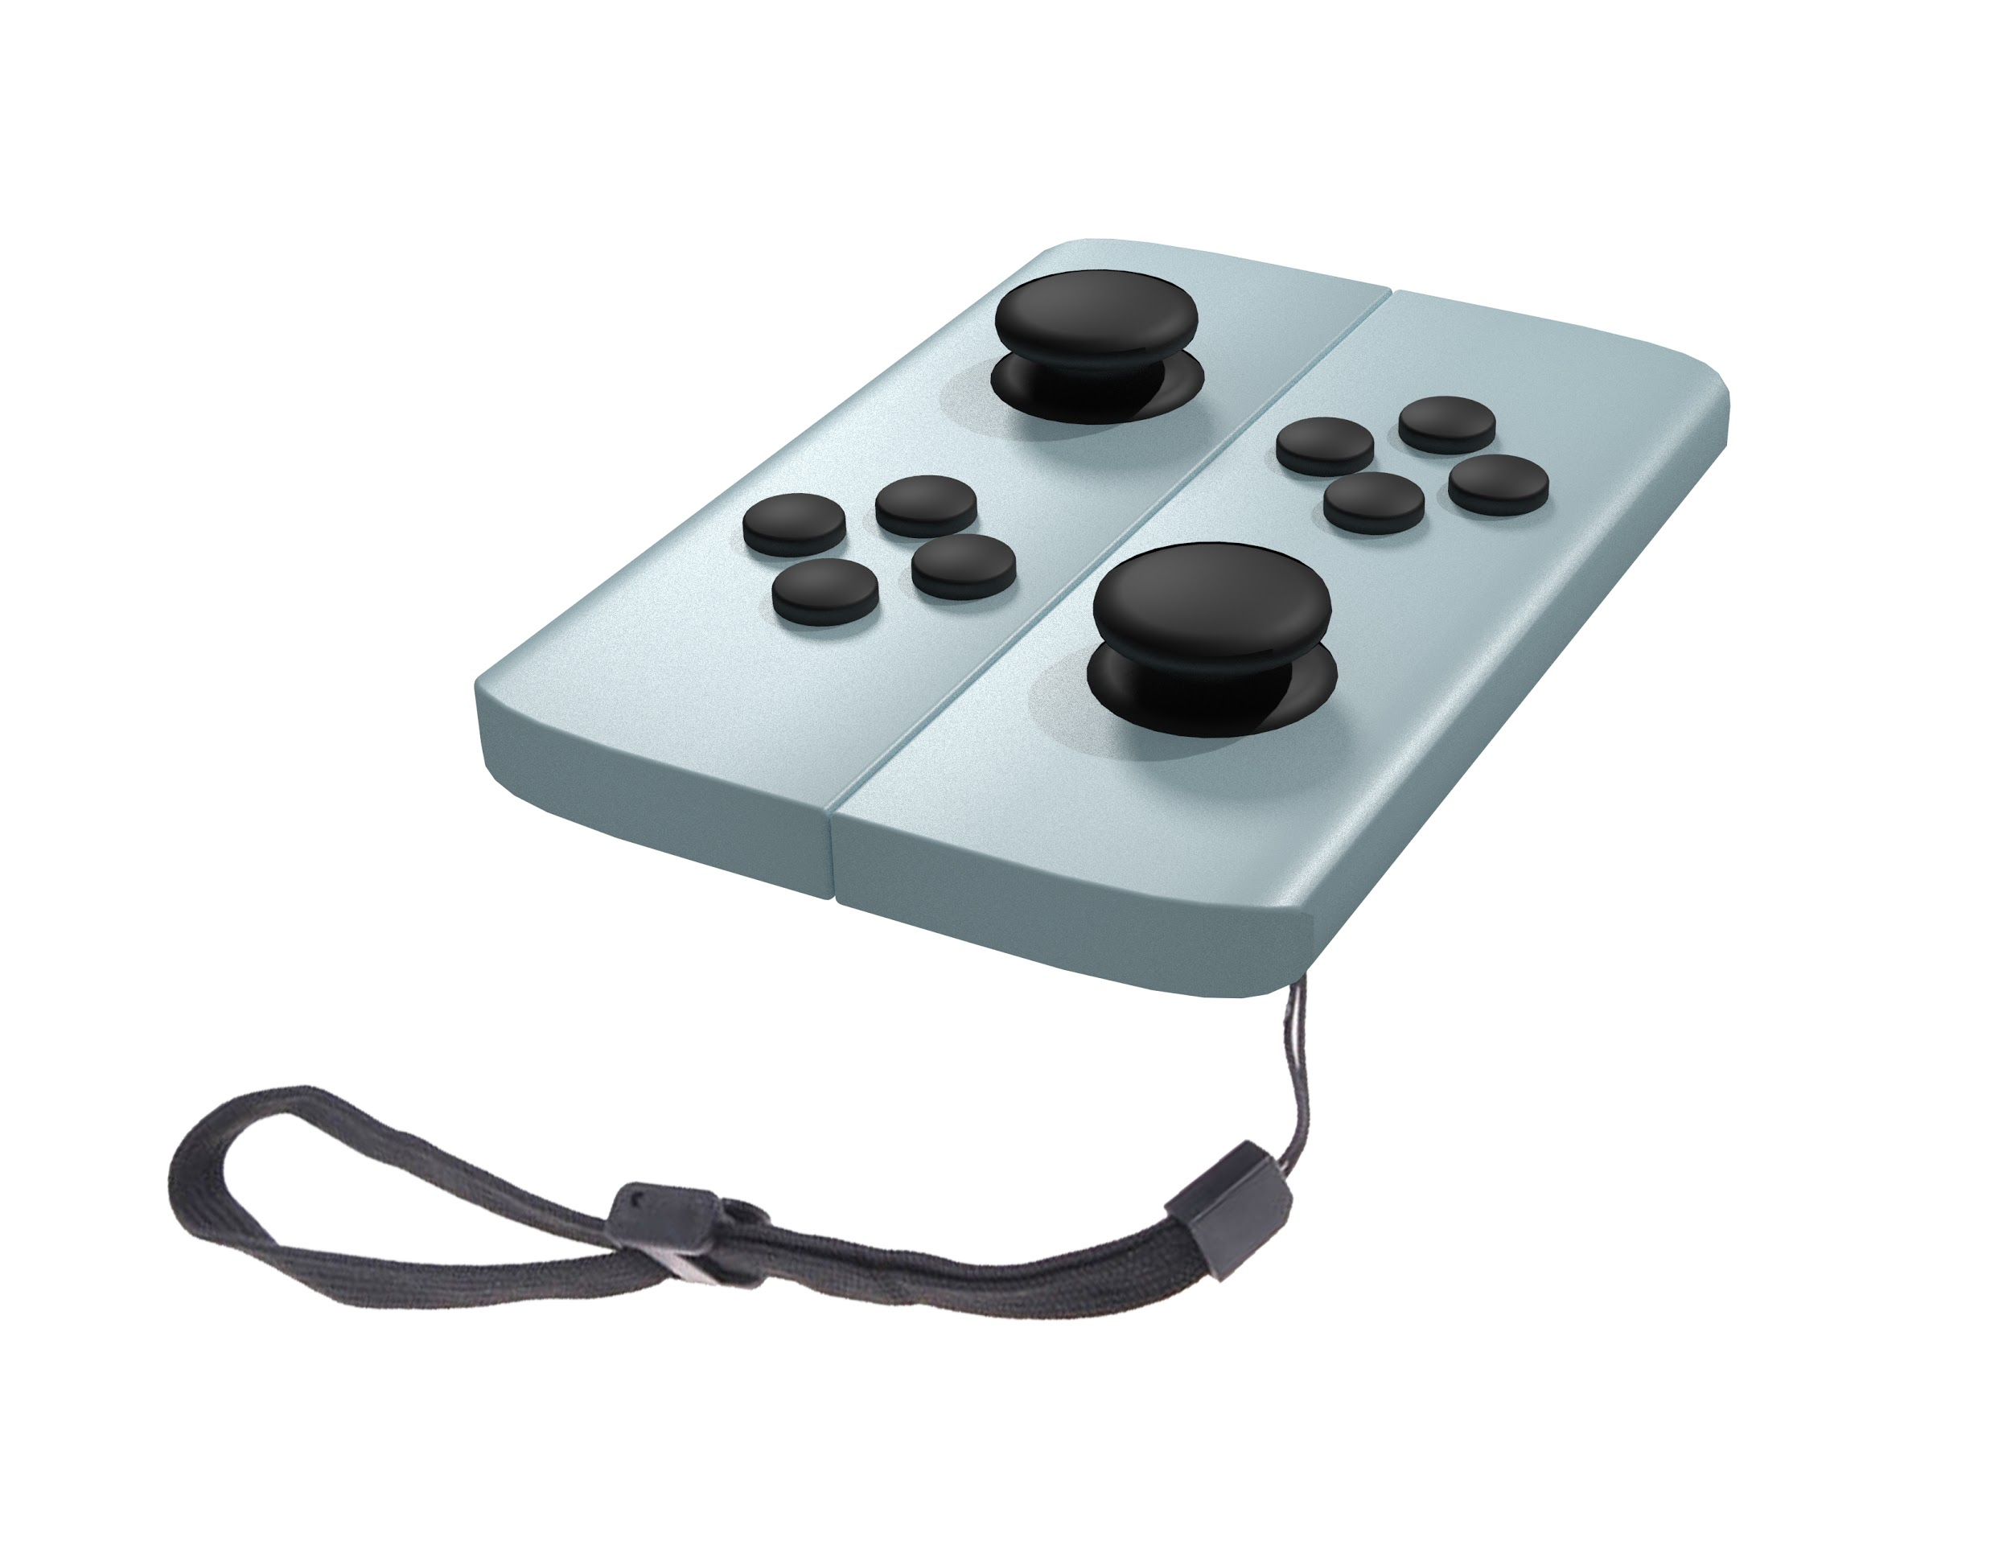

## Holo Boy High-Level Architecture Design

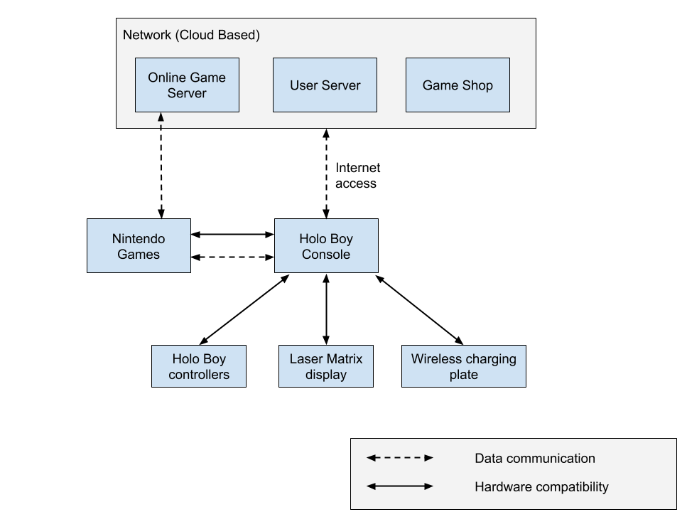

## Holo Boy Intellectual Property

* Intellectual Properties of the Holo Boy handheld controller:
  + Holographic display
  + Console design
  + Controller design
  + Console OS
  + Magnetic and Gyroscopic stabilizer system
  + IP from current Nintendo franchises shall be re-used for Holo Boy games

## Holo Boy Time Table

* Total estimated development time is **5 years**
  + **6 months** of staff training and onboarding
    - During this time we’ll be prioritizing training the hardware engineers so the holographic tech can start development 3 months into staff training.
  + **3 years** of holographic tech development
    - This takes the bulk of development time due to the technology not being fully implemented.
  + **18 months** of Console/Controller development
    - Since the basic design of the console and controller are based off of the Switch, the development should only take around 18 months, this can start in the last 9 months of the holographic tech development as the basic hardware should be finalized by then.
  + **15 months** of operating system development
    - The OS is largely based off of the Switch, therefore reducing the usual OS development time. This will be starting halfway into the console design and development for the same reason as the console development starting during the holographic tech.
  + **15 months** launch title development
    - For our launch titles, most of them will be remakes of classic games to demonstrate to players how holographic technology can change and improve them. Because of this, the development of launch titles should only take around 15 months.
  + **3 months** of releasing the console
    - The last 3 months of our development are for the launch of our console, sending shipments to retailers and advertisements.

### Holo Boy Development Gantt Chart

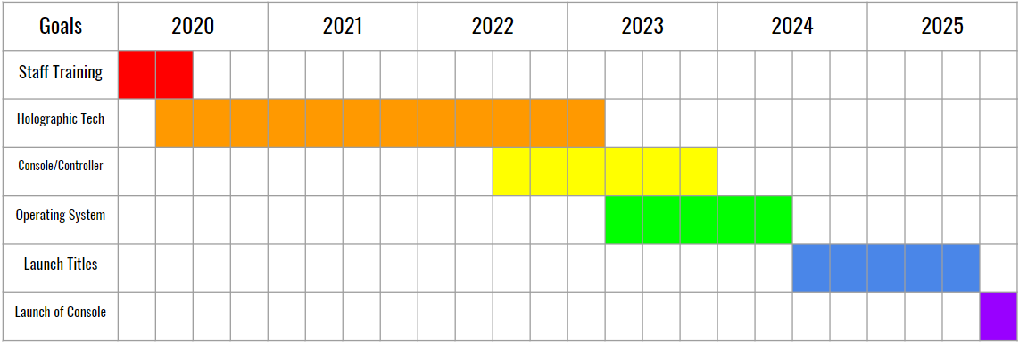

# Holo Boy Team Structure and Skill Set

## Full-Time Employee Positions

Development for the Holo Boy requires a core team of eight full-time employee positions: hardware engineer, software engineer, systems engineer, hardware test engineer, senior embedded hardware engineer, electrical engineer, full stack developer, and a marketing coordinator.

### Hardware Engineer

* **Hard skills:** Circuit designing, Instrumentation and electrical measurements, Control systems and machinery
* **Soft skills:** Visual communication, Research, Resourcefulness

### Software Engineer

* **Hard skills:** C++, Data Structures, Operating System Design
* **Soft skills:** Teamwork skills, Visual communication, Problem solving

### Systems Engineer

* **Hard skills:** Developing systems with multi-function threads, Develop concepts that advance entire project pipeline
* **Soft skills:** Delicate writing skills, Ability to work closely with other disciplines, Manage multiple environments at once, Communication to remove barriers between departments

### Hardware Test Engineer

* **Hard skills:** CAD design experience, Ability to read and comprehend complex technical specifications, Strong debugging and troubleshooting skills
* **Soft skills:** Being able to track and analyze failure trends, Communicate recommendations with engineers, Data analysis skills

### Senior Embedded Hardware Engineer

* **Hard skills:** Computer chip design, C++, Signal Processing, Hardware/Software Integration
* **Soft skills:** Guerilla engineering mentality, Strong leadership and mentorship skills, Communication skills among team members

### Electrical Engineer

* **Hard skills:** PCB design, Schematic design, Analog electronics design
* **Soft skills:** Communication, Teamwork skills, Able to work hands-on

### Full Stack Developer

* **Hard skills:** Knowledge and understanding of how to implement frameworks and API’s, Development experience in HTML, CSS, Javascript, C#, React, NodeJS, AngularJS, Can work with design software like Adobe Photoshop and Adobe Illustrator, Comfortable integrating back end and front end implementation
* **Soft skills:** Always looks for ways to adapt and modify work to reach visual perfection, Passionate about design and creation, and has fun doing it, Leverages technical and design knowledge to bridge communication between UX goals and UI goals

### Marketing Coordinator

* **Hard skills:** Working knowledge of HTML, Experience with wordpress software (Microsoft Word, Adobe inDesign), Can calculate and analyze Return on Investment (ROI), Experience with Marketing Automation Tools (IBM Marketing Cloud)
* **Soft skills:** Strong presentation, writing, and communication skills, Successfully conveys working knowledge and information regarding individual products when communicating to varying dynamics of individuals, Accommodates varying levels of technical knowledge when selling a product to different individuals, Experience collaborating with Stakeholders and high-powered people

## Job Descriptions

### Hardware Engineer Job Description

* Bachelor’s in Electrical Engineering or higher education
* Minimum of 5 years hardware design experience
* Has professional experience creating hardware from design phase to build phase using popular hardware designers, such as Altium, and tools such as, oscilloscopes, logic, and spectrum analyzers
* Working knowledge of RF, high-speed signals, transmission lines, differential signals, power supplies, clock and data timing, EMI mitigation techniques, etc.
* Is able to design multiple circuit boards with schematic captures, printed circuit boards (PCBs), and bill of materials (BOM)
* Effectively utilizes popular schematic editors to demonstrate hardware prototypes
* Detail oriented
* Strong verbal and written communication skills
* Self-starter who works well on small teams

### Software Engineer Job Description

* Bachelor’s in Computer Science or equivalent experience
* Minimum of 5 years relevant experience
* Strong knowledge and understanding of all aspects of software product development
* Experience in programming embedded and application software for video game platforms and related development tools
* Strong skills in working in systems development, development tools, or low level drivers.
* Knowledge of software project tracking and source control
* Strong systems design, problem solving, and debugging skills

### Systems Engineer Job Description

* Master’s in Engineering or Computer Science, or equivalent experience
* 6+ years of industry experience in product development
* Experiencing developing systems with multi-function threads
* Experience mentoring team members
* Experience managing hardware development projects
* Experience working collaboratively to manage system maturation

### Hardware Test Engineer Job Description

* Bachelor’s in Electrical Engineering and/or 10+ years of relevant experience.
* Strong electrical engineering fundamentals
* Knowledge of Visual Basic or C/C++
* Demonstrates strong design and test skills
* Strong interpersonal, influencing, leadership, verbal and written communication skills
* Hands-on experience in the development of consumer electronic products is desired
* Demonstrated system engineering experience of a moderately complex to complex product (smartphones/game controllers/hands-on experience launching complex consumer electronics)

### Senior Embedded Software Engineer Job Description

* Bachelor's degree in Electrical Engineering, Computer Engineering or Computer Science (prefered masters degree in engineering)
* 10+ year’s experience in the consumer or industrial electronics industry as an embedded systems design engineer.
* Hands-on experience with system development and product integration of digital electronics software, including RTOS development and device driver development.
* Experience with hardware schematics and board bring-up.
* Demonstrated shipping at least 2 products from concept to production.
* Experience in embedded C, C++, or Java programming.
* Familiar with test equipment and methods.
* Interested and able to travel
* Experience in working with cross-functional teams and partnering closely with electronics engineers to deliver fully integrated real-world solutions.

### Electrical Engineer Job Description

* Bachelor’s in Electrical Engineering and part of the engineer guild
* Experience on controller design.
* Strong electrical engineering fundamentals
* Basic knowledge of Visual Basic or C/C++
* Demonstrates strong design and test skill
* Demonstrated system engineering experience of a moderately complex to complex product (smartphones/game controllers/hands-on experience launching complex consumer electronics)

### Full Stack Developer

* Bachelor’s in Computer Science, Software Engineering, or a related degree (or equivalent work experience)
* 4+ years working with both front end and back end
* Working experience with all of or a combination of the following languages: HTML, CSS, Javascript, C#, React, NodeJS, AngularJS, Jade, MySQL, ASP.net
* Experience designing application interfaces
* Experience with console system interfaces is a plus
* Has a strong portfolio that demonstrates the ability to integrate back end and front end implementation
* Can bridge communication between the technical UX designers and the visual UI designers. An understanding of what can and can’t be done, and how to communicate between UX and UI about how to approach what can be done is needed.
* Expresses a desire to equally collaborate with the technical implementation and the visual design of an interface

### Marketing Coordinator

* Bachelor's Degree
* 5+ years experience in marketing products
* Basic knowledge and understanding of current popular hardware, software (video games) on the market
* Can determine ROI’s and analyze previous ROI’s to make accurate marketing estimations specific to production and sale locations
* Proficient in Outlook, Excel, Word, and Powerpoint
* Demonstrates excellent communication skills
* Has previous experience marketing major product releases that had successful results
* Repeated marketing success
* Takes discretion and accounts for confidentiality (proprietary and trade secret products) when communicating with varying people (stakeholders, high-power people, distributors, customers, etc.)
* Proactive in approaching marketing solutions
* Organized - we sometimes mess up dates and locations. We need someone who is deeply, obsessively organized and makes sure the projects get done!
* Flexible - You need to be comfortable when plans change when things go wrong. We need someone with a cool head and a can-do attitude

## Interview Loop

1. Collect and analyze resumes of all applicants.
2. See if each applicant’s resume matches up with the requirements needed for the position. Applicants whose experience and work history match up with our requirements advance to the next stage.
3. For positions whose responsibilities include writing code, we will ask them to do an online programming test before they get the chance to have a phone interview. For positions that would not require code writing, they can advance to the phone interview right away.
4. The phone interview involves technical questions based on the position and also questions that elaborate on their work history. Some questions are be soft skill questions based on how they talk about their work experience. The overall phone interview majorly tests communication skills, but also soft skills like leadership, quick thinking, creativity, and ingenuity with various soft skill questions. Light technical questions are asked to see if what they said about their experience matches up with their knowledge. If a candidate passed the phone interview, they are invited to have an in-person interview.
5. The in person interview consists of some small talk, behavioral questions to further understand their soft skills, technical questions, and answering any questions they have about the position.
   1. The small talk is used to ask the candidate to tell themselves a little about who they are and why they are interested in Nintendo. This is to make the candidate more comfortable with the interview. The small talk then transitions into questions about their work history and experience.
   2. The interviewer uses what the candidate says about their work history and experience to ask questions that test their soft skills (communication, collaboration, team work, empathy, creative thinking, problem solving). If nothing about their work history or experience applies, these soft skill questions can just be asked directly.
   3. The interview then moves on to technical questions depending on the position they are applying for. Any coding questions would use a whiteboard. Our main expectation is that the candidate communicates throughout the code problem and talks with the interviewer while working through the problem.
   4. Lastly, the interviewer answers any questions the candidate has about the position. Too much information about the new technology is not given, but the interviewer is allowed to say Nintendo is developing a new console and answer general questions about what the candidate will be doing in the position.

## Interview Questions

Interview questions are broken down into general questions asked for all positions designed to test soft skills and technical questions designed for each specific position.

### General Interview Questions

1. Tell me about yourself in two sentences.
2. Why are you interested in working for Nintendo?
3. Ask to elaborate on job positions of interest on each applicant’s resume.
4. Do you prefer written or verbal communication?
5. Your teammates are all in agreement on how to approach a task, but you disagree. What do you do? How do you react?
6. What do you expect from your manager?
7. What is the most difficult change you’ve encountered in your career?
8. Which describes you best: “done is better than perfect” or “everything has to be perfect?”
9. Do you tend to work overtime?
10. Tell me about a time when you planned and executed a large project. What was the outcome?

### Hardware Engineer Interview Questions

1. What are the effects of a mismatched circuit?
2. Talk about a circuit that implements the provided truth table using only NAND gates. A B OUT 0 0 1 0 1 1 1 0 0 1 1 1
3. If you increase the width of a PCB trace, does it decrease or increase the trace impedance?
4. A double-elimination tennis tournament has n teams. At the end of the tournament how many games have been played?
5. Design a system that records our current conversation and sends it to the HR department.

### Software Engineer Interview Questions

1. You have a 100 coins laying flat on a table, each with a head side and a tail side. 10 of them are heads up, 90 are tails up. You can't feel, see or in any other way find out which side is up. Split the coins into two piles such that there are the same number of heads in each pile.
2. Given two words (beginWord and endWord), and a dictionary's word list, find the length of shortest transformation sequence from beginWord to endWord, such that: Only one letter can be changed at a time and each intermediate word must exist in the word list.
3. Write a function to raise a number to a power.
4. Given an array of numbers, replace each number with the product of all the numbers in the array except the number itself without using division.
5. Describe and make an algorithm that returns the first duplicate character in a string.

### Systems Engineer Interview Questions

1. Can you host multiple https sites with different domain names but same IP on the same server? How?
2. What is the difference between RAID 0 & RAID 5?
3. You have 8 pennies, 7 weight the same, one weighs less. You also have a judge’s scale. Find the one that weighs less in less than 3 steps.
4. Given a page size and a number, align the number with the nearest page. (Note: This was a phone interview question. The interviewer and I used an online document to share ideas about this problem.
5. There is a body of water that starts with 1 square unit, and doubles in size every day (2 units after 2 days, 4 units after 4 days). It takes 100 days to fill up. How many days would it take to fill if you started with 2 square units?

### Hardware Test Engineer Interview Questions

1. How would you test RAM?
2. If the input signal to an ADC is a perfect sine wave but the output spectrum of the ADC shows significant odd harmonics, what is wrong with the ADC?
3. How would you test a buffer using oscilloscope and other devices?
4. What is the difference between CDMA and GSM?
5. Derive the differential equations of motion for a given mechanical system and calculate the transfer function.

### Senior Embedded Software Engineer Interview Questions

1. Write a program to test endianness of storage.
2. Why do we use volatile in C?
3. Implement a string copy function and show if there are any limitations of this function. What if the 2 buffers passed to the string copy function overlaps?
4. How would you design an elevator system. Additionally, are there any problems (from a embedded system point of view) you should prevent and how would you prevent them in your design.
5. Given a continuous block of memory, design a FIFO data cache with the interface get_data() and put_data().

### Electrical Engineer Interview Questions

1. If a conveyor motor trips out, how do you diagnose it?
2. Draw the circuit for an active low-pass filter.
3. How do you represent a real-world quantity in a digital system?
4. A boat is in a swimming pool and there is a rock in the boat. What happens to the level of water if the rock is thrown out of the boat?
5. If you had 2 6-sided dice, what's the probability you get a 7?

### Full Stack Developer Interview Questions

1. Give an example from your portfolio that you are particularly proud of and why it is important to you.
2. Have you ever had to manage conflict or misunderstandings in a full stack development position? What did you learn?
3. UI designers have created a prototype design that they invested a lot of work into, but the UX team does not think it is possible. How would you approach this?
4. You need to implement a simple navigational tool for users to browse video games. What language would you use and why?
5. Reviewing the following UX implementation: what would you change?

### Marketing Coordinator Interview Questions

1. What is the most successful product you have marketed and what do you believe you contributed to the success of the product’s sales?
2. What do you believe is the most important aspect to marketing?
3. We plan to release a AAA video game. How would you market the video game and how would you handle release and shipping strategies?
4. You are a marketing representative at a video game expo. Show us how you would communicate to customers/fans.
5. How do you calculate return on investment (ROI)?

# Skill Training

## New Hires

New hires for the Holo Boy project receive a Nintendo “First Day” orientation where they get familiar with the company culture and expectations. The first day orientation covers company policies, practices, personal days, disciplinary procedures, choosing a health insurance plan, and going over any employee discounts. We also want to paint a picture for our team about what we value as a company, and how we want out employees to represent those values. For example, we value innovation and creativity, so as a company we encourage educated risk taking.

On their second day, they are told in detail about the Holo Boy project, shown high-level architecture diagrams, and given information on where Nintendo currently is in the project. They are then brought together with existing team members for skill training for the Holo Boy project. It is also important that our trainees learn how we function as a company in regards to our communication methods, our scheduling methods, the overhead involved with the job, and how a team functions overall.

## Training

### On the Job Training

For such a hands-on, experimental project, on-the-job training will be used with our developers in Nintendo to get newer members up-to-speed faster. On the job training allows our engineers to contribute to their teams while also becoming more experienced and better equipped developers.

In this way, we can reduce costs as our team spends less time on training curriculums, and use the productivity of their training towards the accomplishment of team goals. On the job training also provides our developers with a real world sense of the working environment, expectations of coworkers, and the standards established by management.

### Lectures

Senior staff who are most involved with the Holo Boy will organize lectures for new hires and existing team members to get up-to-date on the current status and plans for the Holo Boy project. The lectures feature many question-and-answer periods, to make sure all employees understand the goal of the Holo Boy project.

Lectures serve as a time where staff on the Holo Boy project learn about milestones, the current agenda of the team, the expectations of management, and any new details that management has acquired that may benefit the team. Lectures also serve as a time where developers are reminded of the specifications which Holo Boy is meant to satisfy.

### Written Material

After the lectures, all employees are given written material detailing the Holo Boy project to use as a reference while they work on it. This written material consists of time schedules, the standards for code conventions and documentation, and also details about data structures and abstract objects being used by the development team. Code documentation in training is used to outline interfaces, describe the coupling of classes, and also detail the runtime of algorithms and access operations. Written material is used in training to serve as a physical resource for employees, placing all the information an employee may need in one concise location.

# Performance Goals

## Individual & Team Assessments

Individual Assessments

* Individuals are assessed on their last tasks done by program managers during monthly assessment meetings. In these assessments, managers observe the individuals metrics for the week, and discuss those metrics with the employee. Metrics include lines of code, the amount of bugs found in their code by testing, and the amount of deliverables they produced since their last individual assessment.
* Meetings with management are also a time where management can communicate their concerns. Management may be concerned about the quality of an employee's work, the employees contribution to the team, or conflicts that they may be having with other members of the team.
* Team members are also assigned for code reviews, where they inspect the code of another team member and fill out a form analysing their work. In this code review, team members must critique their peers code for documentation, coding standards, and bugs. These code reviews are put on file and returned directly to the peer. This way, management can refer to the code reviews in regards to bonuses and promotions. The purpose of code reviews is to make all team members responsible for quality control, so that every developer understands the expectations of management.

Team Assessments

* Teams will conduct bi-weekly reviews, where they meet to discuss the schedule for their deliverables, the challenges that they are facing, and the work that they expect to have done before the next team assessment. These meetings are conducted by the teams supervisor, who facilitate the meeting while also giving individuals an opportunity to ask questions and describe their progress.

## Performance Reviews

Process

Team supervisors send an email before the team meeting to each individual discussing their time spent on each subtask, lines of code written daily and weekly, and efficiency. During the meeting, team members are able to share with the team problems that they may be encountering.

After the team meeting, individuals meet with the team supervisors one-on-one to discuss their performance and how to improve. Individual team members are asked to evaluate themselves, their peers, and their team as a whole in this private one-on-one meeting. Each team member is asked to stack rank their peers, this review is anonymous. Managers also stack rank each member on their team.

Upper-level managers perform a review on the lower-level managers and their teams. They analyze team productivity and give rewards like bonuses to teams who are exceeding performance goals.

Guidelines

To measure the performance of an individual, the email from the team supervisor stating their time spent on each subtask, lines of code written daily and weekly, and efficiency also includes a score of the combination of all these guidelines. The bottom threshold of the score will be 80% in which the individual will be brought in to talk to a superior.

If an employee consistently ranks low on the stack rankings throughout their time on the Holo Boy project, they may be at risk for termination or one of the first candidates to go if there is a potential lay-off.

# Determination of Success

## Key Milestones

* The completion of the development of the holographic technology integrated with our state of the art hardware.
* The completed development of the controller devices that both interact with the console device and maintain hardware components that support the device.
* The completed development of the operating system that supports basic functionality for user interaction with the Holo Boy console device.
* Development of at least 3 AAA video game titles to release at the time of the Holo Boy’s debut launch. Having popular video games to incentivise consumers to purchase the the Holo Boy at launch.
* The launch of the Holo Boy console device. The Holo Boy launch will take place during the Fall near the holidays when consumers spend the most money on luxury products.
* Exponential profit within the year that the Holo Boy is released. Exponential sales over the span of a year will mean that the product’s release has been a success.

## Measuring Success

* Success on the Holo Boy project is monitored with the following metrics and KPIs:
  + A successful Minimum Viable Product (MVP).
  + There are 10+ million console sales within the first year of the Holoboy release.
  + Employees have high satisfaction during the development and maintenance of the Holoboy. Employee satisfaction is important because happy employees lead to happy consumers, and happy employees represent our company in a positive way.
  + Profit on the development of the product versus sales is calculated using the return on investment (ROI) formula. The goal is for the return on investment to be between 12%-15% within the first year of the Holo Boy’s release.
  + The Holo Boy is highly rated by major tech reviewers on YouTube, cable television, and magazines, such as YouTuber Marques Brownlee, CNETTV channel, and WIRED magazine.
  + Consumer reviews on online retail websites provide an average 5-star rating on the Holo Boy.

# Shipping Strategies

When the Holo Boy console device is first released it will have a retail sale price (RSP) of $659.00. With knowledge that the RSP is inflated compared to previous console devices, the Marketing Coordinator is encouraged to advertise the product as being worth the price for consumers. After all, the Holo Boy is entirely new, innovative technology being introduced to the video game industry and previous innovative consoles had inflated prices as well.

The Holo Boy console device shall be sold internationally by in-store retailers as well as online e-commerce retailers. All stores where consumers can purchases other consoles and console games will also be stores that carry the Holo Boy console device on release.

The Marketing Coordinator ensures that there is an accurate distribution of consoles to stores for consumer purchase. The Coordinator should also account for Nintendo’s profit goals in regard to return on investment (ROI) analytics.

Advertisements are conducted in a few different ways, with more being considered by our Marketing Coordinator:

* “Day One” edition Holo Boy console devices will be released in a metallic silver finish and no other version of the Holo Boy will be released in the same design.
* Posters will be provided to in-store retailers of the Holo Boy console for the purpose of displaying them in-store and on display windows.
* Exclusive t-shirts will be provided to in-store retailers for midnight releases of the console.

The Holo Boy console device also includes (1) carrying case and (1) Holo Boy hologram compatible video game. Accessories that consumers are able to purchase, although may not be available upon release, are:

* Themed carrying cases for the Holo Boy console device.
* Controller cases (think smart phone cases).
* Color choices for the Holo Boy console.

With continued sales of the Holo Boy, we will also release a design lab for the console that allows consumers to design their console to their color selection preferences before purchase. In the design lab, consumers will be able to change the controller color, button colors, thumbstick colors, and the color of their carrying case.

# Challenges

The primary challenge is creating something so new and proprietary. One issue may be the availability of parts -- some parts may need to be designed and created from scratch, and therefore may have a high cost while developing the Holo Boy.

Registering patents may be another challenge; we don’t want to let our technology be figured out too soon, lest we risk ruining surprise for the consumer and spurring any competition to take action.

Training developers on the holographic technology also takes time and patience. Since this is new technology, by constantly testing and changing how it phases out, developers need to be constantly in the loop throughout the development of the holographic technology.

Another potential challenge is the risk vs. the reward; this technology will open up a new frontier in the gaming industry, but there are many pitfalls and chances of failure. However, with Nintendo’s vision of trying new things, we expect even if the Holo Boy does not become a commercial success, Nintendo will strengthen through the challenges it overcomes while developing this system.

# Resources

Cox, Jospeh. “Nintendo Sues Californian for Selling Modded NES Classic and Switch Hacks,” Motherboard, (Dec. 13, 2018). <<https://motherboard.vice.com/en_us/article/8xpekz/nintendo-sues-switch-modded-nes-classic-pirate-californian>>, accessed Mar. 21, 2019.

Good, Owen. “Nintendo sued by peripheral maker alleging Switch design infringes patents,” Polygon, (May 6, 2018). <<https://www.polygon.com/2018/5/6/17324594/nintendo-switch-sued-patent-infringement-gamevice>>, accessed Mar. 21, 2019.

“Japan: Employee Statistics From Nintendo,” My Nintendo News, (Mar. 1, 2019). <<https://mynintendonews.com/2019/03/01/japan-employee-statistics-from-nintendo>>, accessed Mar. 21, 2019.

Rad, Chloe & Otero, Jose. “Nintendo Reveals Restructuring Plans,” IGN, (Sep. 14, 2015). <<https://www.ign.com/articles/2015/09/14/nintendo-reveals-restructuring-plans>>, accessed Mar. 21, 2019.